Welcome To
Trinity Lutheran Church
Lutheran Church—Missouri Synod
A Stephen Ministry Congregation

1354 South Otsego Avenue
Gaylord, Michigan 49735
Church Phone: (989) 732-4816

Church Email: secretary@trinitygaylord.com
www.trinitygaylord.com

Office Hours: Monday through Friday 9am – 1pm

OUR PURPOSE
…is to LOVE GOD, LOVE OTHERS, AND SERVE THE WORLD by worshiping the Lord Jesus, bringing our members into Christ-like maturity, and equipping them through Word and Sacrament for their mission and ministry. We go heart to heart into the world with Jesus, sharing His love, caring for one another, praying, and bringing the lost into a relationship with Christ, by the working of the Holy Spirit.

October 2, 2022
Seventeenth Sunday after Pentecost
Preacher: Rev. Paul Schneider

ABOUT OUR WORSHIP
We welcome all who gather here today! We are blessed to celebrate together the mercy, grace, and love we have from God through the death and resurrection of our Lord Jesus Christ.

Children: Families with children are very welcome here. Having children in church is important so they can begin to learn about their faith in Jesus, and it’s good for the whole congregation to see. Please feel comfortable keeping “squirmy” kids in the service. This is where they belong, too!

Pew Cards: Guests and Members, please fill out the Guest/Member card located on the back of the pew in front of you and pass it to the end of the aisle. If you forget you can put it in the offering plate on your way out.

If standing is difficult: Please feel free to remain seated during any portion of the service. Please let an Elder or Usher know if you need communion in your pew seat.

About our celebration of Holy Communion: We celebrate the Lord’s Supper in the confession and glad confidence that, as he says, our Lord gives into our mouths not only bread and wine but his very body and blood to eat and to drink for the forgiveness of sins and to strengthen our union with him and with one another. Our Lord invites to his table those who trust his words, repent of all sin, and set aside any refusal to forgive and love as he forgives and loves us, that they may show forth his death until he comes.

Because those who eat and drink our Lord’s body and blood contrary to that which is stated above do so to their great harm, and also because Holy Communion is a confession of the faith which is confessed at this altar. Anyone who is not yet instructed, in doubt, or who hold a confession differing from that of the Lutheran Church—Missouri Synod, and yet desire to receive the sacrament, are asked first to speak with Pastor. Those not communing are still invited to come forward for a blessing from Pastor, and you may indicate this by crossing your arms over your chest.
TTTTTT
GREETING

P Peace be with you.
C And also with you.
P Let us Pray

T ORDER OF SERVICE T
(The liturgy is from Divine Service Setting four LSB pg. 203ff)

OPENING HYMN
O God, Our Help in Ages Past LSB 733 sts. 1–3
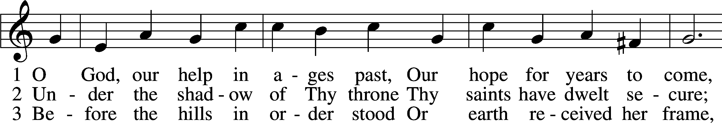
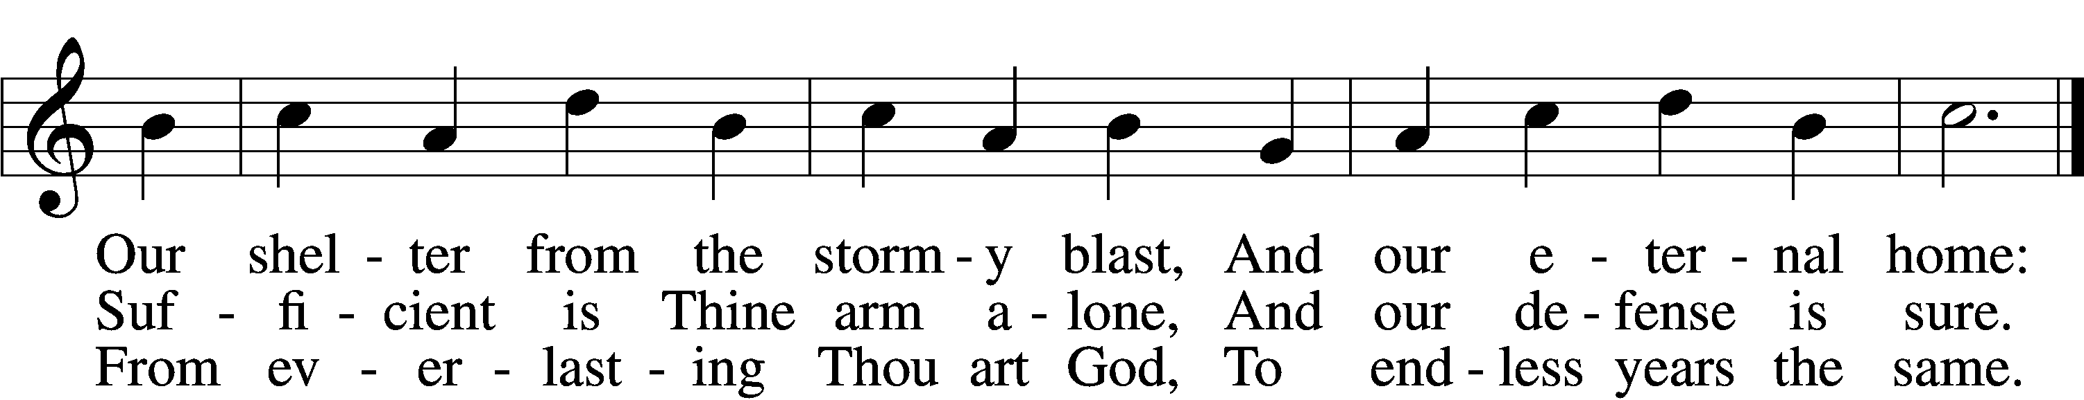
Text: Isaac Watts, 1674–1748, alt.
Tune: William Croft, 1678–1727
Text and tune: Public domain

Please stand as able
CONFESSION and ABSOLUTION
The sign of the cross may be made by all in remembrance of their Baptism.

P In the name of the Father and of the T Son and of the Holy Spirit.
C Amen.
P Our help is in the name of the Lord,
C who made heaven and earth.
P If You, O Lord, kept a record of sins, O Lord, who could stand?
C But with You there is forgiveness; therefore, You are feared.

P Since we are gathered to hear God’s Word, call upon Him in prayer and praise, and receive the body and blood of our Lord Jesus Christ in the fellowship of this altar, let
us first consider our unworthiness and confess before God and one another that we have sinned in thought, word, and deed, and that we cannot free ourselves from our sinful condition. Together as His people let us take refuge in the infinite mercy of God, our heavenly Father, seeking His grace for the sake of Christ, and saying: God, be merciful to me, a sinner.
C Almighty God, have mercy upon us, forgive us our sins, and lead us to everlasting life. Amen.
P Almighty God in His mercy has given His Son to die for you and for His sake forgives you all your sins. As a called and ordained servant of Christ, and by His authority, I therefore forgive you all your sins in the name of the Father and of the T Son and of the Holy Spirit.
C Amen.
SERVICE OF THE WORD
KYRIE LSB 204
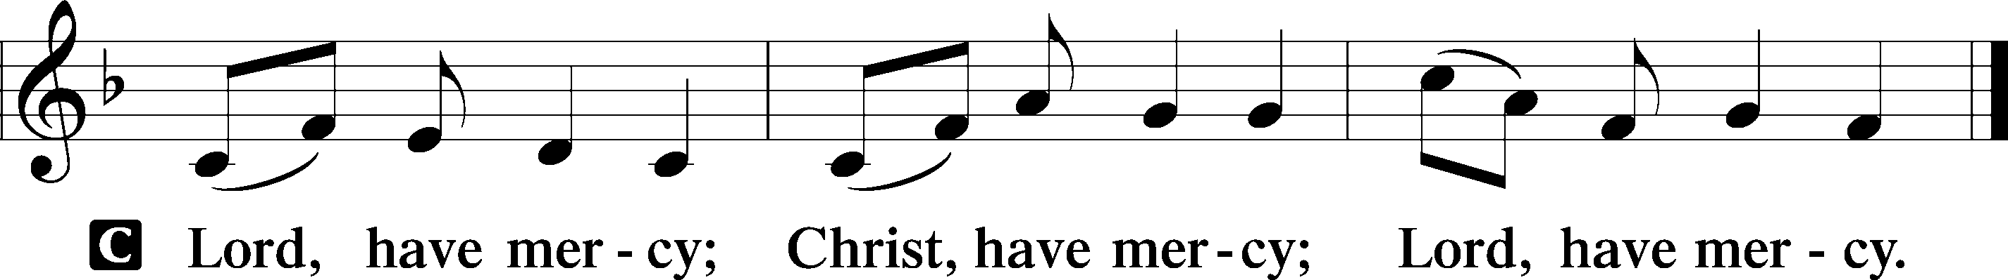

HYMN OF PRAISE
Serve The Lord With Gladness Tune: LSB 662

“Serve the Lord with gladness!” It is He alone
Who redeemed us sinners, Guides us as His own
To enjoy the blessings Of His love and Grace.
Will at last in glory Meet us face to face.
Onward, then to Jesus! Let this be our aim:
“Serve the Lord with gladness! Glorify His name.

“Serve the Lord with gladness!” He gave us command
To proclaim His Gospel Now in every land
So that fellow sinners May, like us, be blest.
Leading them to Jesus, We can serve Him best.
Onward, then, for Jesus! Let this be our aim:
“Serve the Lord with Gladness!” Glorify His name!

“Serve the Lord with gladness!” There’s no grater joy
Than to serve the Master, in His employ.
As we build His kingdom Angels, to rejoice
Over every sinner Brought to hear His voice,
Onward. then for Jesus! Let this be our aim:
“Serve the Lord with Gladness!’ Glorify His name!
SALUTATION AND COLLECT OF THE DAY
P The Lord be with you.
C And also with you.
P Let us pray.
O God, our refuge and strength, the author of all godliness, by Your grace hear the prayers of Your Church. Grant that those things which we ask in faith we may receive through Your bountiful mercy; through Jesus Christ, Your Son, our Lord, who lives and reigns with You and the Holy Spirit, one God, now and forever.
C Amen.
Please be seated

OLD TESTAMENT READING Habakkuk 1:1–4; 2:1–4
^{1:1}The oracle that Habakkuk the prophet saw. ²O Lord, how long shall I cry for help,
²O Lord, how long shall I cry for help, and you will not hear? Or cry to you “Violence!” and you will not save? ³Why do you make me see iniquity, and why do you idly look at wrong? Destruction and violence are before me; strife and contention arise. ⁴So the law is paralyzed, and justice never goes forth. For the wicked surround the righteous: so justice
goes forth perverted. 9:1¹I will take my stand at my watch post and station myself on the tower, and look out to see what he will say to me, and what I will answer concerning my complaint. ²And the Lord answered me: “Write the vision; make it plain on tablets, so he may run who reads it. ³For still the vision awaits its appointed time; it hastens to the end—it will not lie. If it seems slow, wait for it; it will surely come; it will not delay. ⁴“Behold, his soul is puffed up; it is not upright within him, but the righteous shall live by his faith.”
P This is the Word of the Lord.
C Thanks be to God.

EPISTLE 2 Timothy 1:1–14
¹Paul, an apostle of Christ Jesus by the will of God according to the promise of the life that is in Christ Jesus, ²To Timothy, my beloved child: Grace, mercy, and peace from God the Father and Christ Jesus our Lord. ³I thank God whom I serve, as did my ancestors, with a clear conscience, as I remember you constantly in my prayers night and day. ⁴As I remember your tears, I long to see you, that I may be filled with joy. ⁵I am reminded of your sincere faith, a faith that dwelt first in your grandmother Lois and your mother Eunice and now, I am sure, dwells in you as well. ⁶For this reason I remind you to fan into flame the gift of God, which is in you through the laying on of my hands, ⁷for God gave us a spirit not of fear but of power and love and self-control.
⁸Therefore do not be ashamed of the testimony about our Lord, nor of me his prisoner, but share in suffering for the gospel by the power of God, ⁹who saved us and called us to a holy calling, not because of our works but because of his own purpose and grace, which he gave us in Christ Jesus before the ages began, ¹⁰and which now has been manifested through the appearing of our Savior Christ Jesus, who abolished death and brought life and immortality to light through the gospel, ¹¹for which I was appointed a preacher and apostle and teacher, ¹²which is why I suffer as I do. But I am not ashamed, for I know whom I have believed, and I am convinced that he is able to guard until that Day what has been entrusted to me. ¹³Follow the pattern of the sound words that you have heard from me, in the faith and love that are in Christ Jesus. ¹⁴By the Holy Spirit who dwells within us, guard the good deposit entrusted to you.

P This is the Word of the Lord.
C Thanks be to God.

Please stand as able

ALLELUIA AND VERSE

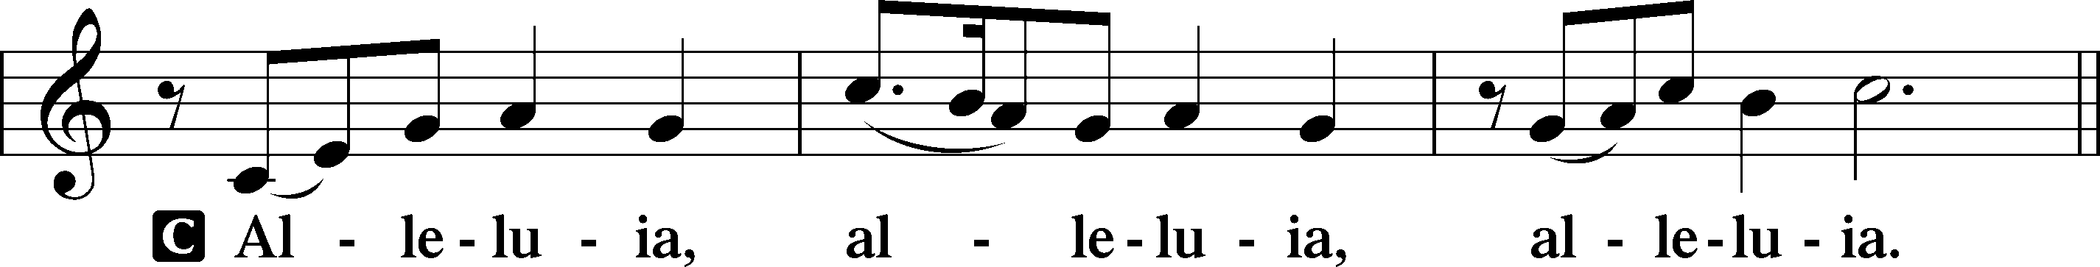
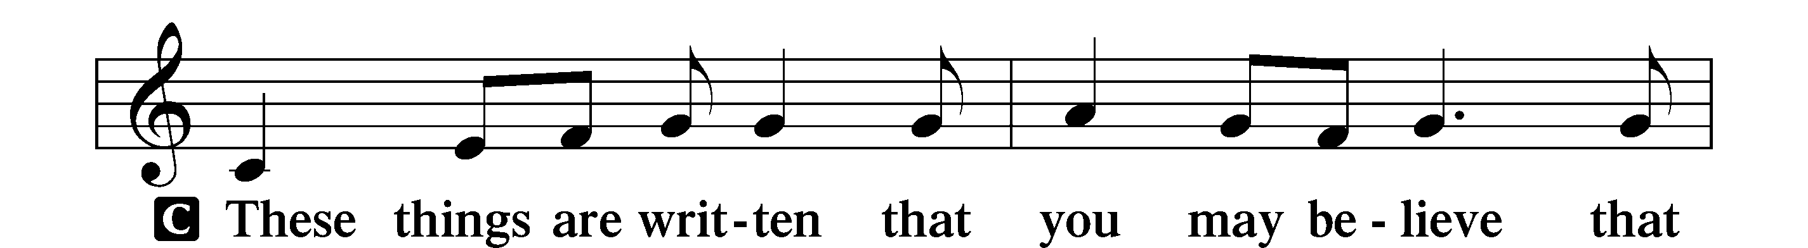
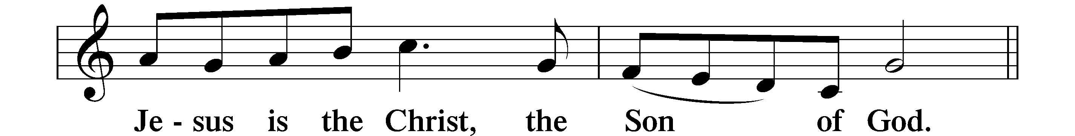
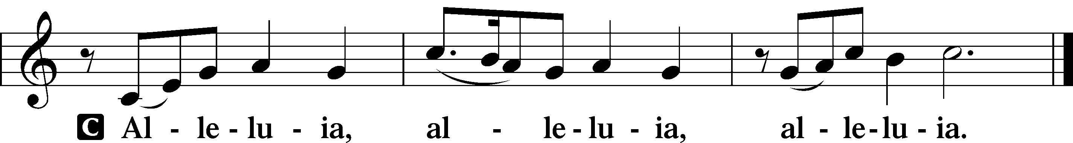

HOLY GOSPEL Luke 17:1–10
P The Holy Gospel according to St. Luke, the seventeenth chapter.
C Glory to You, O Lord.

¹[Jesus] said to his disciples, “Temptations to sin are sure to come, but woe to the one through whom they come! ²It would be better for him if a millstone were hung around his neck and he were cast into the sea than that he should cause one of these little ones to sin.
³Pay attention to yourselves! If your brother sins, rebuke him, and if he repents, forgive him, ⁴and if he sins against you seven times in the day, and turns to you seven times, saying, ‘I repent,’ you must forgive him.”
⁵The apostles said to the Lord, “Increase our faith!” ⁶And the Lord said, “If you had faith like a grain of mustard seed, you could say to this mulberry tree, ‘Be uprooted and planted in the sea,’ and it would obey you.
⁷“Will any one of you who has a servant plowing or keeping sheep say to him when he has come in from the field, ‘Come at once and recline at table’? ⁸Will he not rather say to him, ‘Prepare supper for me, and dress properly, and serve me while I eat and drink, and afterward you will eat and drink’? ⁹Does he thank the servant because he did what was commanded? ¹⁰So you also, when you have done all that you were commanded, say, ‘We are unworthy servants; we have only done what was our duty.’”

P This is the Gospel of the Lord.
C Praise to You, O Christ.

NICENE CREED
C I believe in one God,
the Father Almighty,
maker of heaven and earth
and of all things visible and invisible.
And in one Lord Jesus Christ,
the only-begotten Son of God,
begotten of His Father before all worlds,
God of God, Light of Light,
very God of very God,
begotten, not made,
being of one substance with the Father,
by whom all things were made;
who for us men and for our salvation came down from heaven
and was incarnate by the Holy Spirit of the virgin Mary
and was made man;
and was crucified also for us under Pontius Pilate.
He suffered and was buried.
And the third day He rose again according to the Scriptures
and ascended into heaven
and sits at the right hand of the Father.
And He will come again with glory to judge both the living and the dead,
whose kingdom will have no end.
And I believe in the Holy Spirit,
the Lord and giver of life,
who proceeds from the Father and the Son,
who with the Father and the Son together is worshiped and glorified,
who spoke by the prophets.
And I believe in one holy Christian and apostolic Church,
I acknowledge one Baptism for the remission of sins,
and I look for the resurrection of the dead
and the life T of the world to come. Amen.
Please be seated
ALL GOD’S CHILDREN – TALK

SERMON HYMN
I Know My Faith Is Founded LSB 587
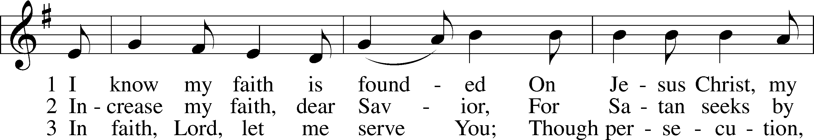
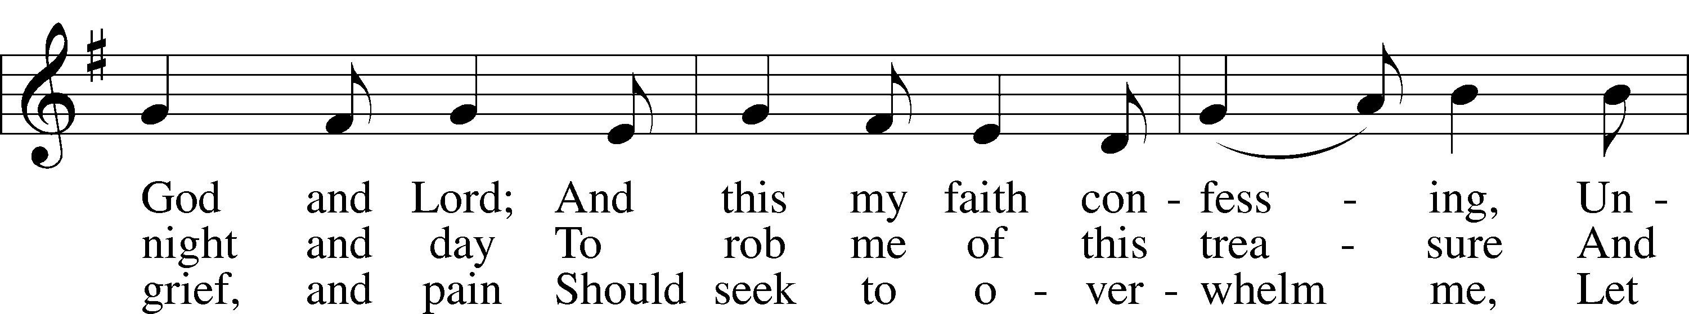
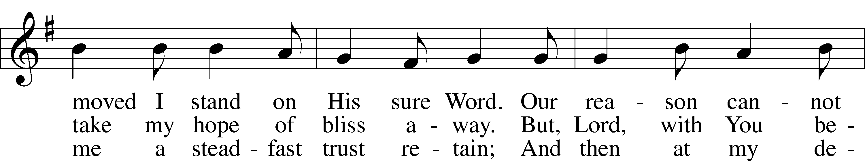
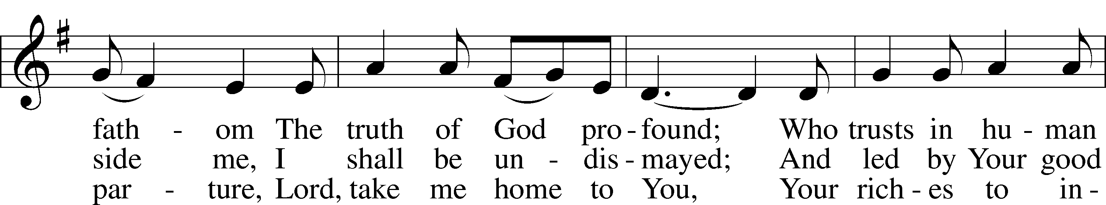
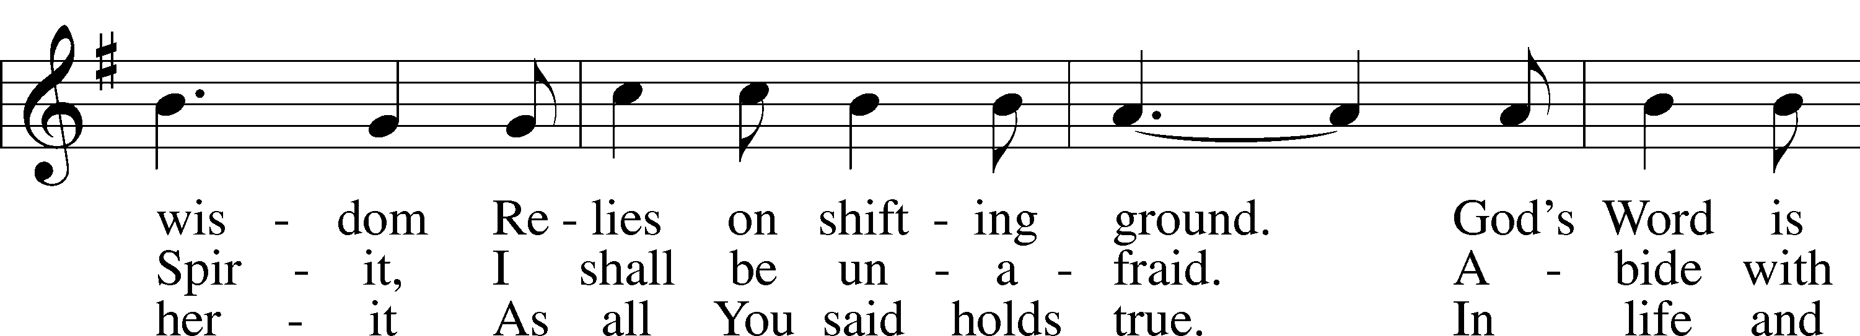
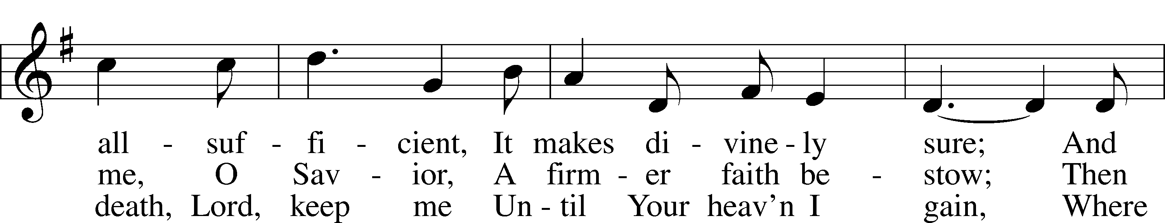

Continued on next page.
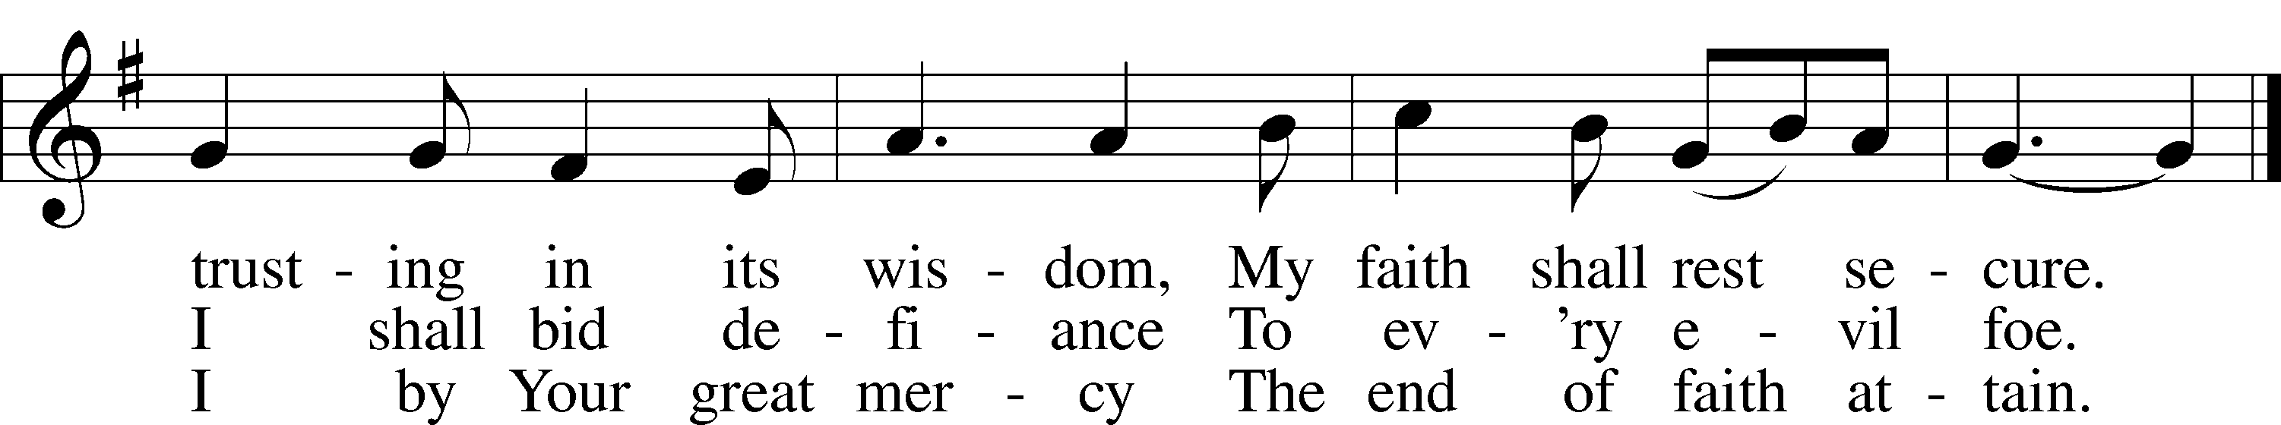

SERMON
Please stand as able
PRAYER of the CHURCH
After each Segment:
P Lord, in Your Mercy,
C Hear our Prayer.
After Final Segment:
P Hear us as we pray in His name and as He has taught us:
LORD’S PRAYER
C Our Father who art in heaven,
hallowed be Thy name,
Thy kingdom come,
Thy will be done on earth
as it is in heaven;
give us this day our daily bread;
and forgive us our trespasses
as we forgive those
who trespass against us;
and lead us not into temptation,
but deliver us from evil.
For Thine is the kingdom
and the power and the glory
forever and ever. Amen.

T SERVICE of the SACRAMENT T

PREFACE LSB 208
P The Lord be with you.
C And also with you.
P Lift up your hearts.
C We lift them to the Lord.
P Let us give thanks to the Lord our God.
C It is right to give Him thanks and praise.
P It is truly good, right, and salutary that we should at all times and in all places give thanks to You, O Lord, holy Father, almighty and everlasting God, for the countless blessings You so freely bestow on us and all creation. Above all, we give thanks for Your boundless love shown to us when You sent Your only-begotten Son, Jesus Christ, into our flesh and laid on Him our sin, giving Him into death that we might not die eternally. Because He is now risen from the dead and lives and reigns to all eternity, all who believe in Him will overcome sin and death and will rise again to new life. Therefore with angels and archangels and with all the company of heaven we laud and magnify Your glorious name, evermore praising You and singing:
SANCTUS LSB 208
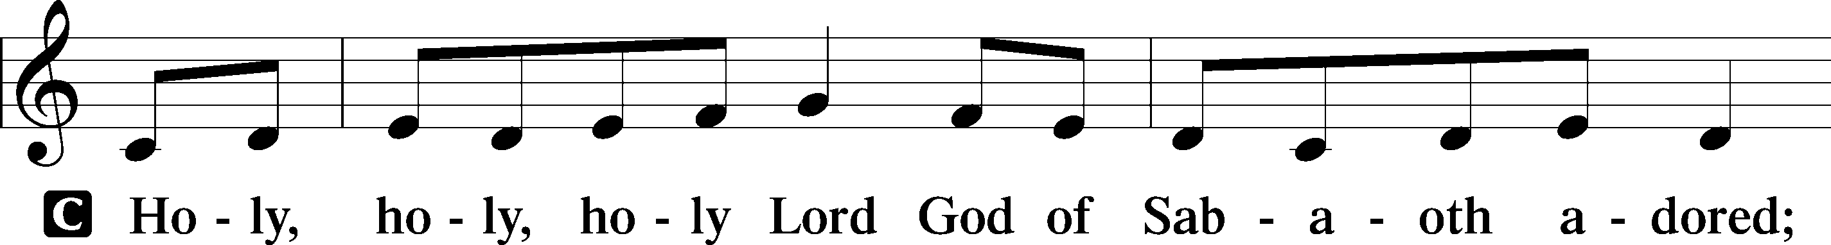
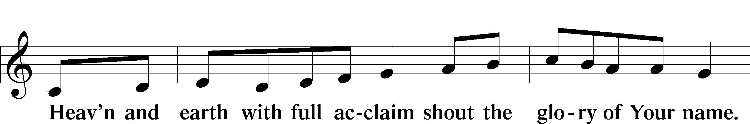
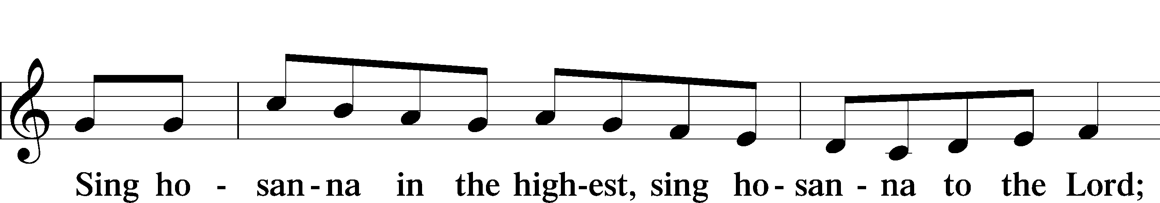

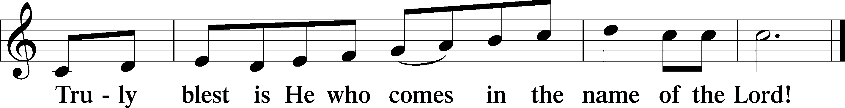

PAX DOMINI
P The peace of the Lord be with you always.
C Amen.

AGNUS DEI
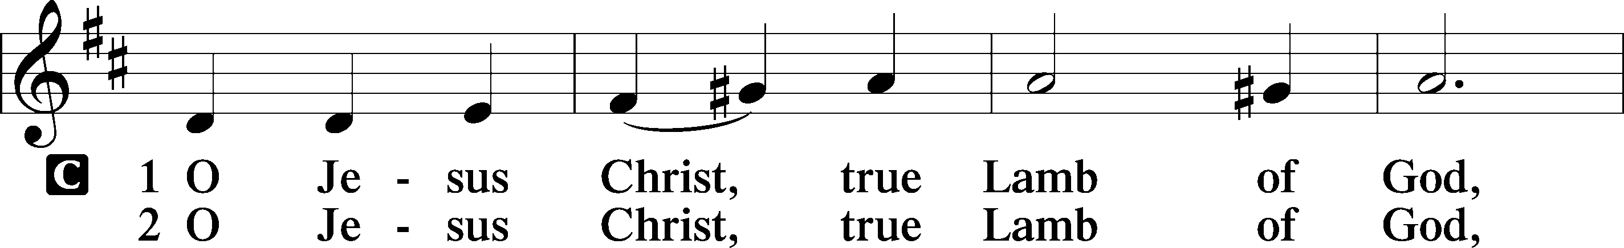
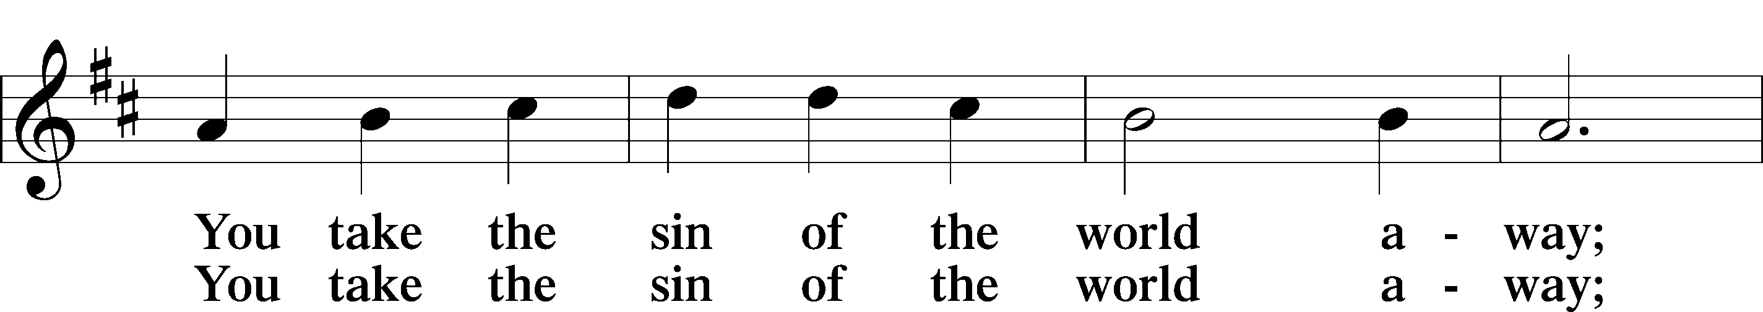
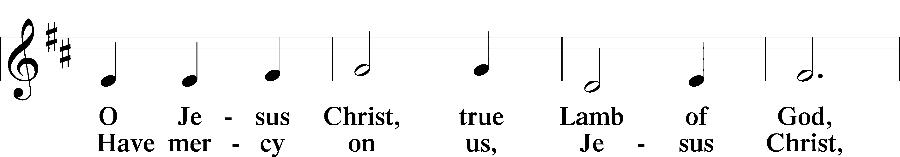
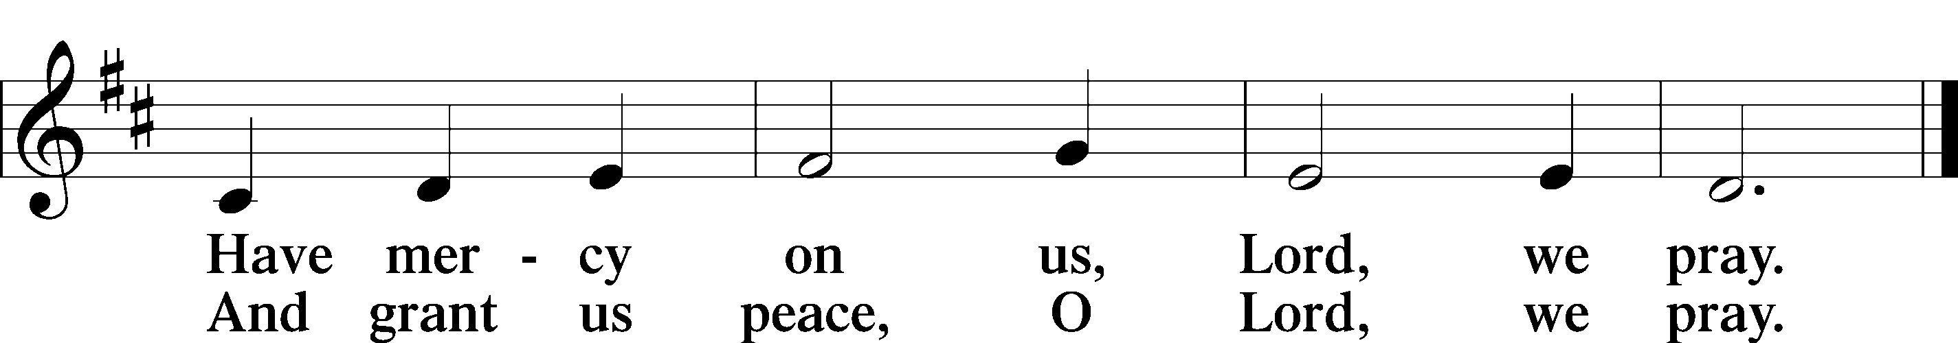

Please be seated

DISTRIBUTION
The pastor and those who assist him receive the body and blood of Christ first, then Communion will be served at the rail. Ushers will help direct you forward via the center aisle; please return to your seats via the side aisles. Gluten-free bread is available for those who need it, as is non-alcoholic grape juice. Simply request either when you come forward to receive Communion.

DISTRIBUTION HYMN
My Hope Is Built on Nothing Less LSB 576
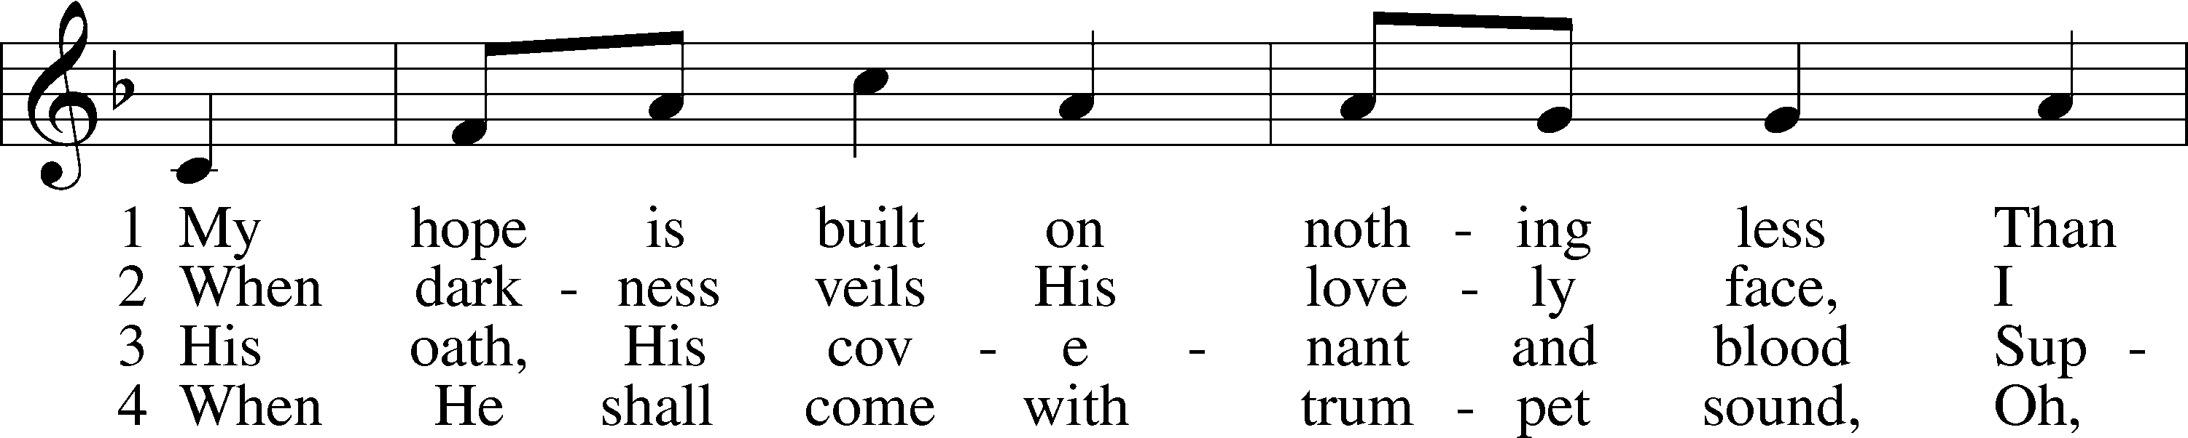
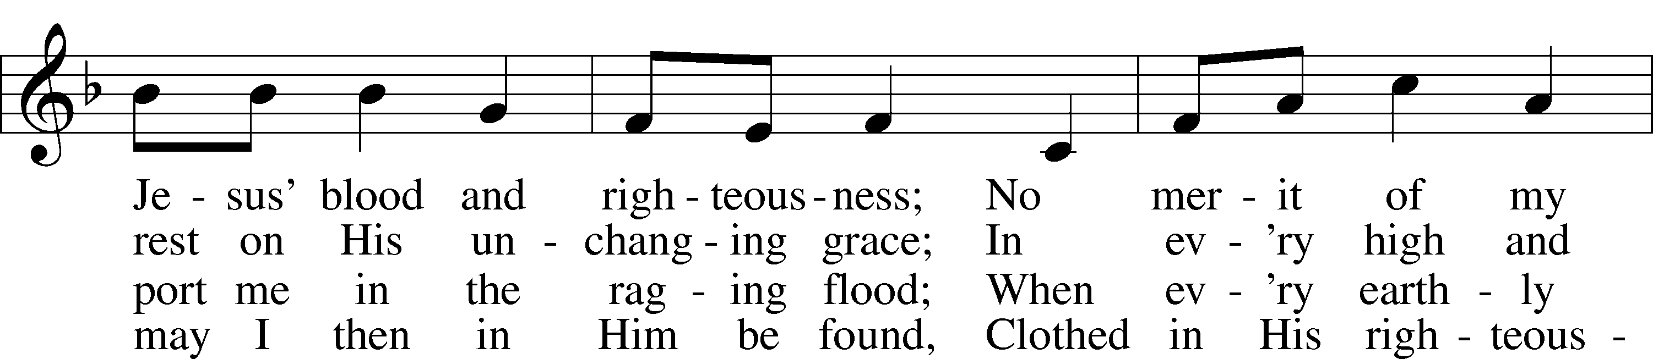
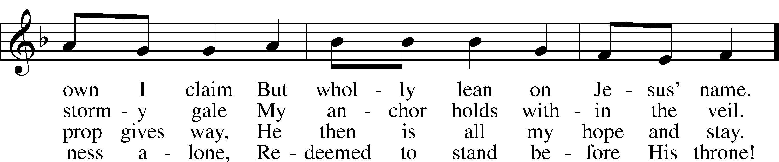
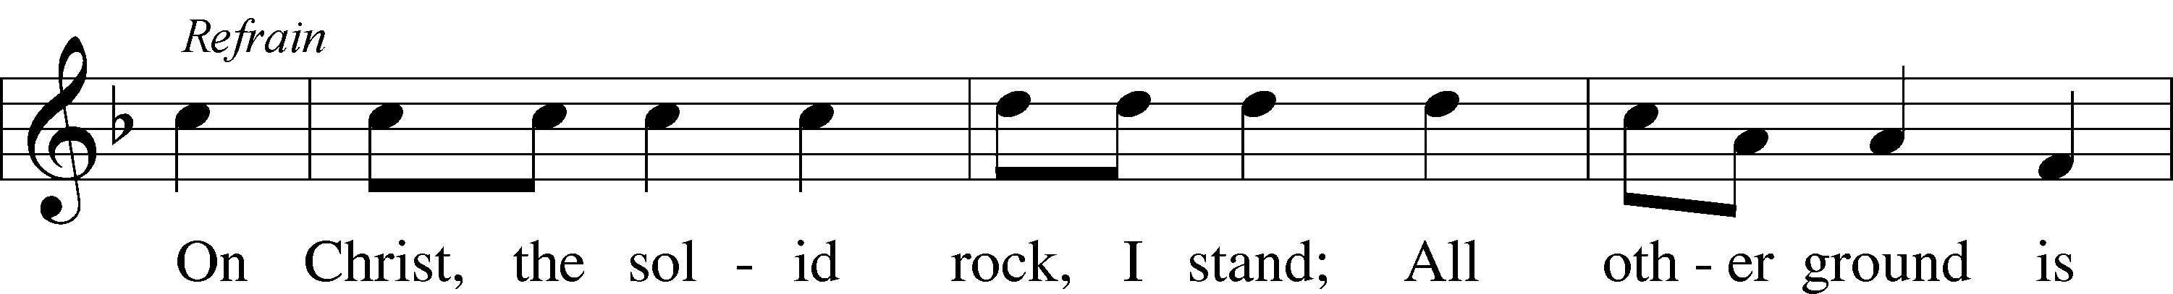
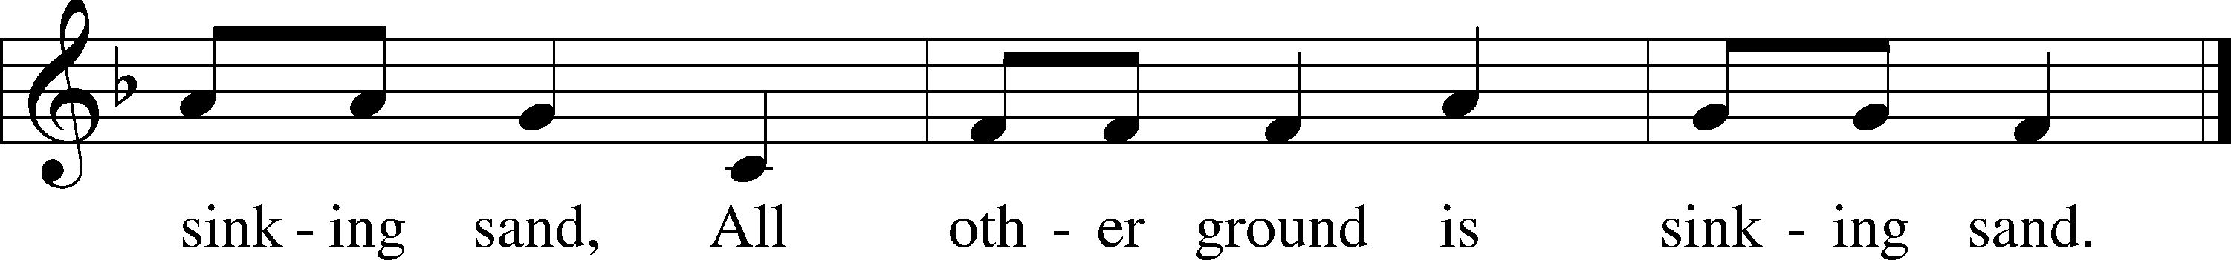
Text: Edward Mote, 1797–1874, alt. Tune: William B. Bradbury, 1816–68 Text and tune: Public domain

DISTRIBUTION HYMN
Your Table I Approach LSB 628 sts. 1–3, 6
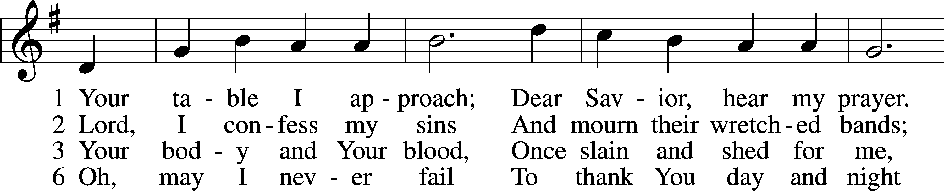
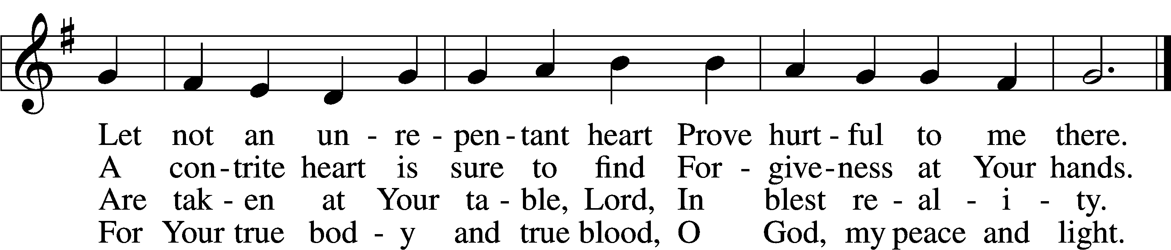

Please stand as able
NUNC DIMITTIS LSB 211
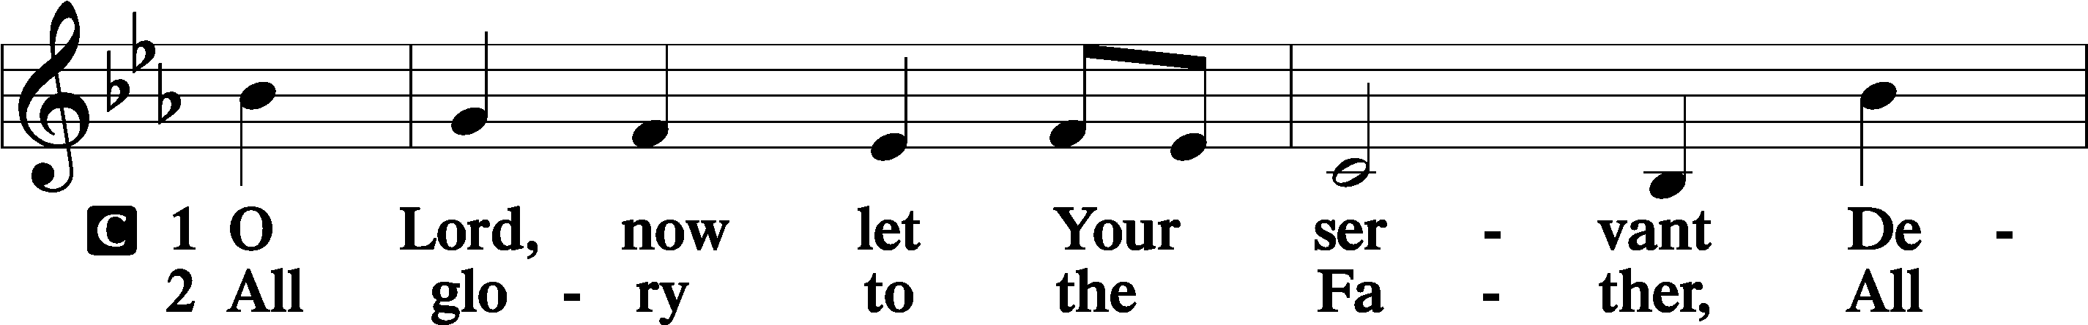
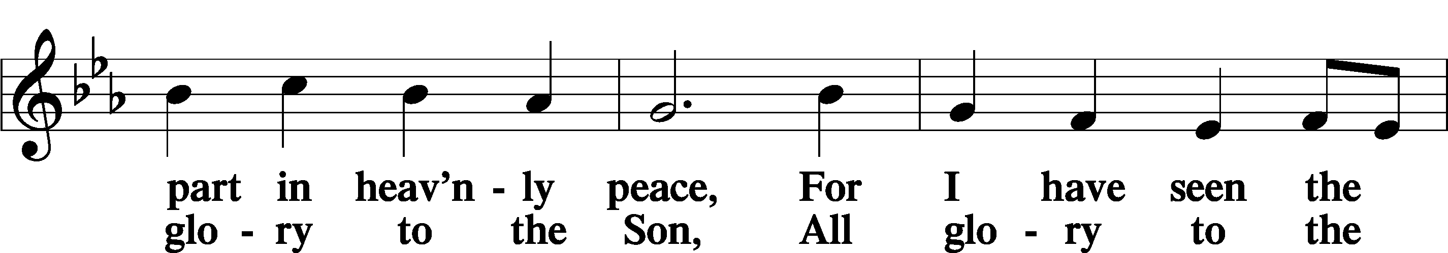
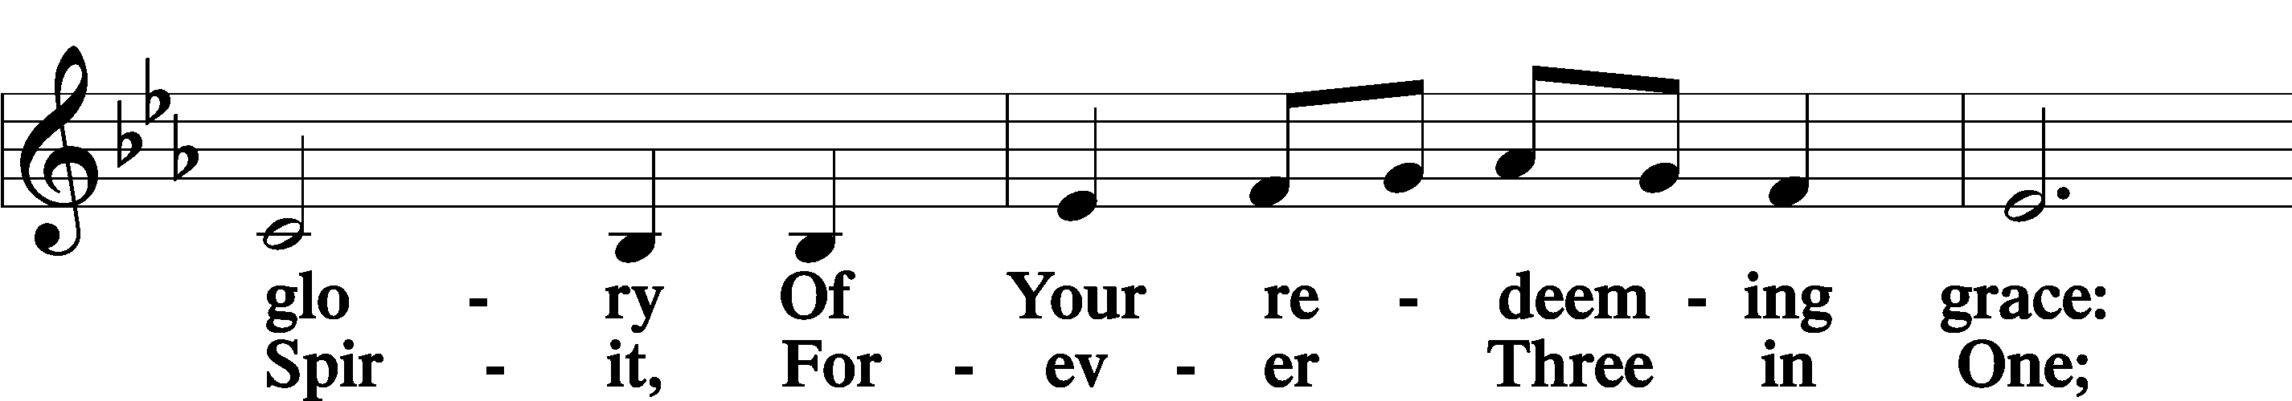
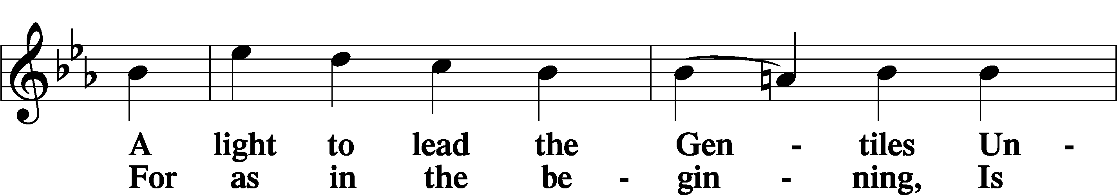
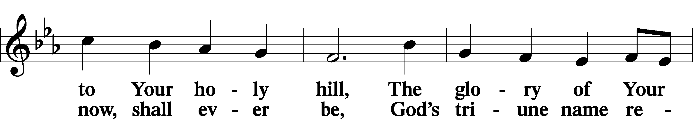
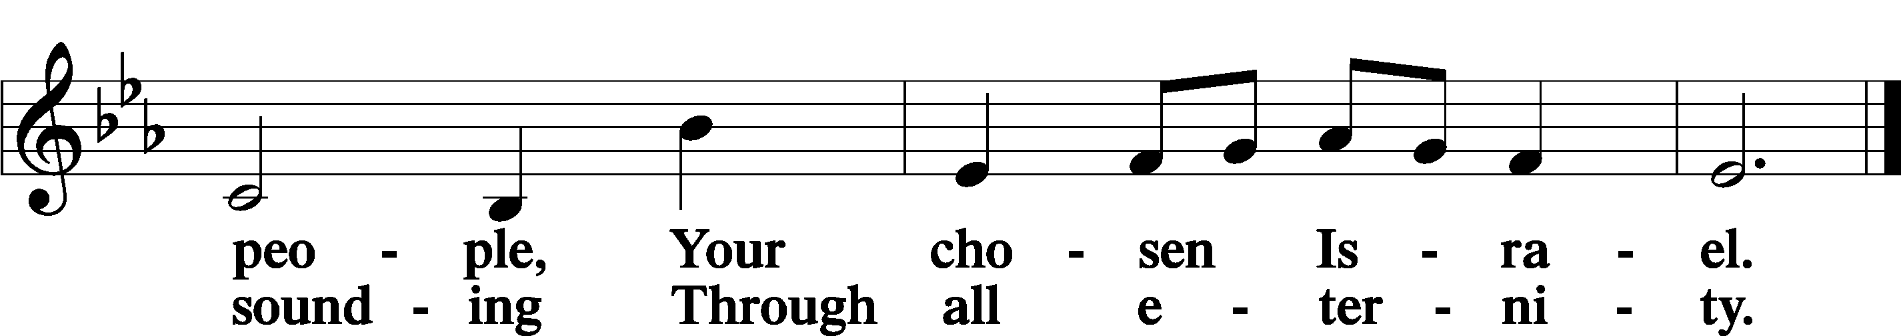

POST COMMUNION COLLECT
P Let us pray.
Gracious God, our heavenly Father, You have given us a foretaste of the feast to come in the Holy Supper of Your Son’s body and blood. Keep us firm in the true faith throughout our days of pilgrimage that, on the day of His coming, we may, together with all Your saints, celebrate the marriage feast of the Lamb in His kingdom which has no end; through Jesus Christ, Your Son, our Lord, who lives and reigns with You and the Holy Spirit, one God, now and forever.
C Amen.

BENEDICAMUS LSB 212
P Let us bless the Lord.
C Thanks be to God.
BENEDICTION
P The Lord bless you and keep you.
The Lord make His face shine on you and be gracious to you.
The Lord look upon you with favor and T give you peace.
C Amen.

Please be seated
CLOSING HYMN
O God, Our Help in Ages Past LSB 733 sts. 4–6
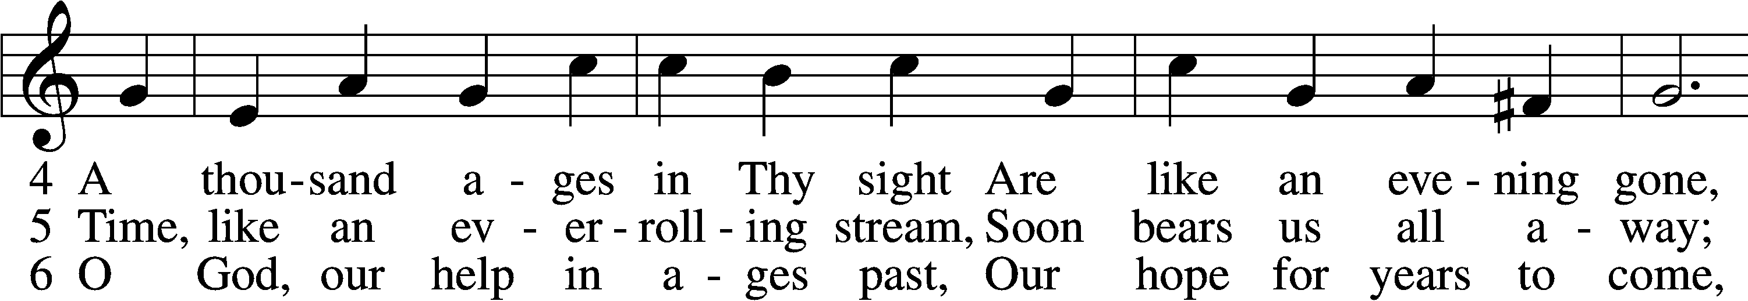
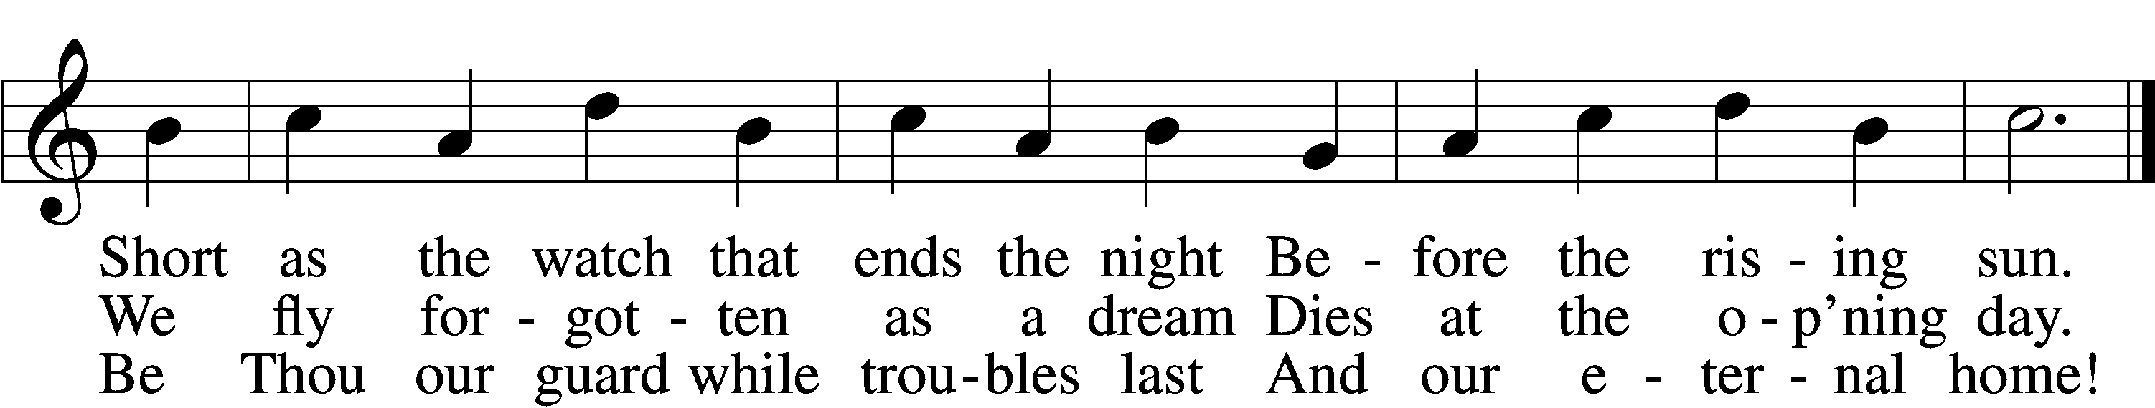
Text: Isaac Watts, 1674–1748, alt.
Tune: William Croft, 1678–1727
Text and tune: Public domain

ANNOUNCEMENTS and SENDING WORDS
P We go to live for Jesus!
C We go to share His love!
Acknowledgments
Unless otherwise indicated, Scripture quotations are from the ESV® Bible (The Holy Bible, English Standard Version®), copyright © 2001 by Crossway, a publishing ministry of Good News Publishers. Used by permission. All rights reserved. Created by Lutheran Service Builde

SERVING IN GOD’S HOUSE TODAY
Pastor: Rev. Paul Schneider
Elder: Tim Arner
Ushers: Terri Raithel, Judy Stutzman (LWML)
Reader: Kathy Erat (LWML)
Greeters: Kathy Erat, Sharron Kato
Counter: Nancy Ely, Sandra Smith
Coffee Servers: LWML (LWML Sunday)
Altar Care: Judi Stutzman
Virtual Organ: Bob Erat
Children’s Talk: Nancy Ely
Bible Study: w/ Dr. Tom Beach
PRAYERS
Please contact the office with updates to the prayer list. People will remain on the prayer list for 4 weeks before being removed. If they need to remain on the list, please keep Elaine informed and of any updates. This will help us to have a more accurate list. Thanks for your cooperation.
Those who continue to grieve the passing of loved ones, The Family of Pam Martin (in-law of Leslie Martin.).
Those with upcoming surgery:
Those recovering from surgery: Kathi Layman, Joann Whitney, Jim (Joann Whitneys brother in law.) and Paul Schneider.
Those with health concerns: Tiffany Amsdill, Ruth Bennett (Sharron Kato’s Sister), Tanner Beyers, Hope Buchinger, Betsy Cook, Kay Gregg, Paul Kietzman, Hilda Koch, Jennifer Martin, Eleanor Raether, Beth Smith, and Judi Stutzman.
Those diagnosed with cancer: Sue Cavanagh (diagnosed with breast cancer). Leah Eicher, Rachel Frisch, Janice Knoellinger, Leslie Martin, Brian Morgan, and Hope Osantowski.
Those under Hospice Home Care: Ken Williamson, Jim (Joann W. brother-in law).

BIRTHDAYS: ANNIVERSARIES
10/4 Matt Boldrey

MESSAGES

ALTAR FLOWERS ALTAR FLOWERS today are given to the glory of God by Linda West in celebration of her daughter’s Wedding.
MEMBER & GUEST CARDS: If you have not filled out a member/guest card, please take the time to fill one out and place it in the plate behind the back pews in our sanctuary.
GREETING CARDS If you are in need of some greeting cards, we carry an array of them. The card cabinet is in the hallway across from the library. The cost of the cards is posted on the cabinet. The money collected from the cards goes to LWML to help support Missions.
CHURCH EXTENSION FUND has proven investment products with measurable results. Since 1901, through dedicated Christian financial management, CEF is focused on funding the needs of Michigan District congregations. (Proven, Dedicated, Focused)
For more information, contact (Congregation Representative and telephone number) or call 800-242-3944.
WEDNESDAY MORNING BIBLE STUDY 10:00am w/ Rev Ken Bernthal
In the Fellowship Hall.
LARGE PRINT WORSHIP FOLDERS: We now have large print worship folders they are on the table in the back of the church with the offerings. Please fill free to take on.
CANCER & FRIENDS SUPPORT GROUP:, we are there for you with our caring, and support. Contact Elaine for more information 989-350-4391 call or text.
SUNDAY MORNING BIBLE STUDY 10:30 AM with Dr. Tom Beach..
PORTALS OF PRAYER: For October- December are in and can be picked up from the shelf in the narthex.

KUT-UPS: the dates for this year are as follows:
Oct. 10 and 24 Nov. 7 and 21 Dec. 5 and 19
FOOD GIVEAWAY: We have confirmed a FOOD GIVEAWAY event for Friday, October 7th here at Trinity! A food truck will deliver the food that morning at about 9:30am, so we need our helpers here by 9am in order to get organized. We are excited about doing this here at our church parking lot once again! Please mark this date on your calendars. We will need LOTS of helpers. A sign-up sheet is posted on the bulletin board across from the church office. Tell your friends about it – we want to share this food with anybody who can use it! And please pray that God will use us in this way to help our community, thereby glorifying Him!
DUAL, PARISH CONGREGATION MEETING: We will be having a Joint congregation meeting Monday October 3 at 6:30 pm at Mt. Hope Grayling. This is to extend a call to Rev James Travis. Thanks, any questions 989-370-5056
LWML Sunday is Today October 2nd. LWML women will be assisting with service activities that day and will participate in assembling Health Kits for Lutheran World Relief after our worship service. Wear your purple on LWML Sunday . There will be a BAKE SALE that day during our Fellowship Hour, with all donations being directed to missions of various kinds.
LWML FALL ZONE RALLY is Saturday, October 8th, at St. Paul Lutheran Church, Kalkaska. There will be a guest speaker, election of officers, and an ingathering. See the bulletin board in the Fellowship Hall for more details. It starts at 10am, with registration at 9:30am. They would like to know how many from our church are attending so that they have enough lunch provisions, so please sign up on the hallway bulletin board if you plan to attend.

THIS WEEK AT TRINITY
October 2 Sunday
9:00 am Worship Service. -Rev. Ken Bernthal
10:00 am Fellowship & Coffee Hour
10:30 am Sunday Morning Bible Study W/ Dr. Tom Beach
Sunday School Room
October 3 Monday
6:30 pm Dual Parish Meeting at Mt. Hope
7:00 pm NO Choir
October 4 Tuesday
3:00 pm Heart of the Pines Quilt Guild (Fellowship Hall)
5:00 pm Ladies Get-together dinner (Applebee’s)
6:30 pm Elders Meeting
October 5 Wednesday
10:00 am Wednesday Morning Bible Study w/ Rev. Ken Bernthal
(Gospel of Mark)
October 6 Thursday
October 7 Friday
9:00am Community food giveaway (Parking Lot)
October 8 Saturday
8:00 am LWML Fall Rally (Kalkaska)
October 9 Sunday
9:00 am Worship Service – Rev. Paul Schneider
10:00 am Fellowship & Coffee Hour
10:30 am Bible Study with Dr. Tom Beach (Sunday School Room)

SERVING IN GOD’S HOUSE NEXT SUNDAY 10/09/2022
Pastor: Rev. Paul Schneider Piano/ Organ: Tom & Jean Beach
Elder: Glenn Smith Children’s Talk: Nancy Ely
Ushers: John & Judi Stutzman Sunday Morning Bible Study:
Greeters: Risa Sherman, Leslie Martin w/ Dr. Tom Beach 10:30am
Counters: Donna Cottrell, Laverne Scheiterlein Altar Care: Nancy Ely
Coffee Servers: Paul & Karen Schneider

